

**STANDARD OPERATING PROCEDURE**

**Do not Photocopy**

**Document Information Classification: Unrestricted**

|  |  |
| --- | --- |
| **Title:** | **Connecting to the TRE with X2Go** |
| **Effective Date:** | **14 Feb 2019** |
| **Reference Number:** | **SOP-03-16** |
| **Version Number:** | **1.6** |
| **Owner:** | **Information Security Manager,** |
| **Review Date:** | **12 Feb 2020** |

Table of Contents

1. Purpose 3

2. Scope 3

3. Responsibilities 3

4. Procedure 3

4.1. Generating SSH Key-Pairs 4

4.2. Installing X2Go 7

4.3. Configuring X2Go 7

4.4. Connecting to the TRE 10

5. Cross-referenced ISMS Documents 11

6. Appendices 11

1. Purpose

This document provides guidance for the connecting to Linux virtual machines within the Trustworthy Research Environment (TRE) using the X2Go client.

1. Scope

TRE user account holders and the computer they will use to connect to a Linux virtual machine within the TRE. This SOP is applicable to users of local workstations and laptops running Microsoft, Apple and Linux operating systems.

1. Responsibilities

The TRE Operations Manager is responsible for:

* Agreeing with software applications will be prescribed for the purpose of transferring TRE data
* Coordinating the testing of software applications in the computing environment corresponding with TRE users’ working environments

The TRE System Administrator is responsible for:

* Ensuring the deployed virtual machines support connections from WinSCP and are compatible with SSH key pairs generated using Putty Key Generator
* Monitoring and logging connections so that support can be provided when necessary

1. Procedure

To setup a connection to the TRE, the following steps must be completed by the TRE user on the PC will be used to connect to the TRE:

1. Create SSH key-pair (private and public key files)
2. Save SSH private key file in a memorable place on PC
3. Send SSH public key to the TRE Service team
4. Configure X2Go client to connect to TRE

The use of SSH key pairs adds a ‘2nd Factor’ into the authentication process, as not only does the user need to **know** something (a passphrase) but they also need to **own** something (an SSH private key).

X2Go allows a Linux machine’s graphical user environment to be controlled remotely, much like Microsoft’s ‘Remote Desktop Protocol’. To connect to a Linux machine within the TRE, X2Go utilises the SSH protocol and authentication is handled via SSH key-pairs.

The TRE, and all systems contained within, is involved in handling information that must be managed in a way that ensures its confidentiality, availability and integrity. Implementing security controls throughout the lifecycle of a system can help the TRE achieve its ISMS objectives, regulatory requirements and the needs of its users.

* 1. Generating SSH Key-Pairs

Each SSH connection to a machine running in the TRE must utilise an RSA SSH Private/Public key-pair.

Download the latest version of Putty Key Generator (puttygen.exe) from

<https://www.chiark.greenend.org.uk/~sgtatham/putty/latest.html>

Putty Key Generator doesn’t get installed in the same way as most software applications, which means a shortcut icon won’t automatically get placed on the desktop or the ‘Start’ menu. Instead, it is necessary to download and place this puttgen.exe file to a permanent location (e.g. C:\Program Files) and run the program by double-clicking on the file. Alternatively, create a shortcut on the desktop to that file.

*Note: Putty Key Generator may already exist on a PC that has previously installed the full Putty package (putty-0.xx-installer.msi).*

**Step 1.** Open Putty Key Generator. Make sure the key type is set to ‘RSA’ and 2048bits. Then click on ‘Generate’ and follow the onscreen instructions for generating ‘randomness’ as per *Figure 1:*

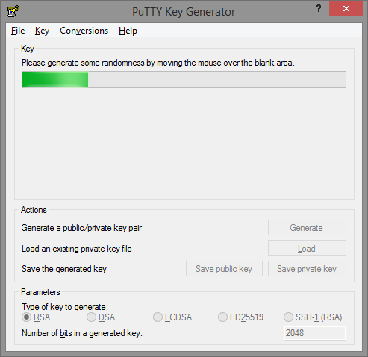

Figure 1

**Step 2.** Once completed, type a strong passphrase (if necessary use document ISMS-03-07 for guidance on creating passwords) into the ‘Key passphrase’ fields, as per *Figure 2:*

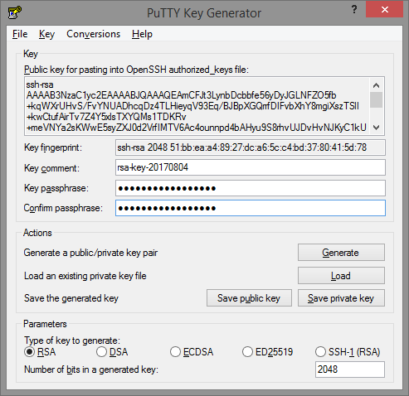

Figure 2

**Step 3.** Click on ‘Conversions’ and select ‘Export OpenSSH key’

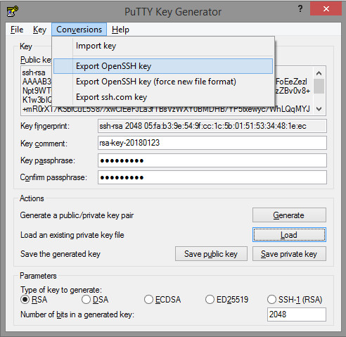

Figure 3

Select a secure and memorable location to save this private key on your PC (and not on a portable storage device that could get lost or stolen) and make a note of the location as it will need to be specified later.

In the Filename field, type a filename using the following format:

Your *TRE Project ID* (e.g. tre-00x) and your *initials*, and the abbreviation *‘prv’*. For example, if your project name is ‘TRE-050’ and your name is John Smith, type in ‘tre-050-js-prv’ and click ‘Save’. Private SSH keys in this format have no file extension.

Next, click on ‘Save public key’ and type in a similar filename as before but with the phrase ‘pub’ at the end. Public SSH keys are also created with no file extension. Following the previous example, the resulting SSH public key will have the following filename: ‘tre-050-js-pub’.

It is OK to save the public key in the same location as the private key, but make sure they are not confused with each other when sharing the public key.

*\*Note: It is important that the SSH private key is only ever stored on the physical hard drive of the computer being used to connect to the TRE. Some University computer’s map the ‘My Documents’ folder to network storage (for example, UoM P:drive), which means files stored in My Documents are not stored locally. However, it is also the case the some UoM workstations don’t allow the user to store anything on the local C: drive, but it might be possible to ask IT Services to allow write-permission to a folder such as ‘C:\ProgramData\. On some UoM workstations, the folder ‘C:\Work’ is writeable by the user.*

* 1. Installing X2Go

The latest version of X2Go must be used to connect to the TRE.

*Note: Some University of Manchester staff workstations are pre-installed with X2Go, but it is usually not the latest version.*

Download the installation file applicable to the operating system of the computer that will be used to connect to the TRE:

<http://wiki.x2go.org/doku.php/download:start>

Install X2Go selecting the default options.

* 1. Configuring X2Go

After installation is complete, run the software and open the ‘New Session’ dialogue from the menu. From the Session Tab, fill in the following as per *figure 4*:

* **Session Name**: type anything you wish here, e.g. name of TRE project
* **Host**: type in the IP address of TRE virtual machine (provided by the TRE service team)
* **Login**: type in the username that will be used to connect to the TRE virtual machine (provided by the TRE service team)
* **Use RSA/DSA key for SSH connection**: type in the path to the SSH private key created in section 4.3
* **Session type:** select ‘XFCE’

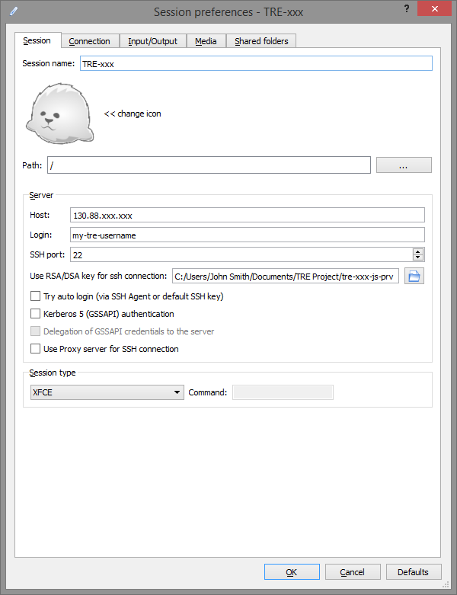

Figure 4

From the Input/Output Tab, configure your preferred screen resolution and disable the Clipboard, as shown in *figure 5*:

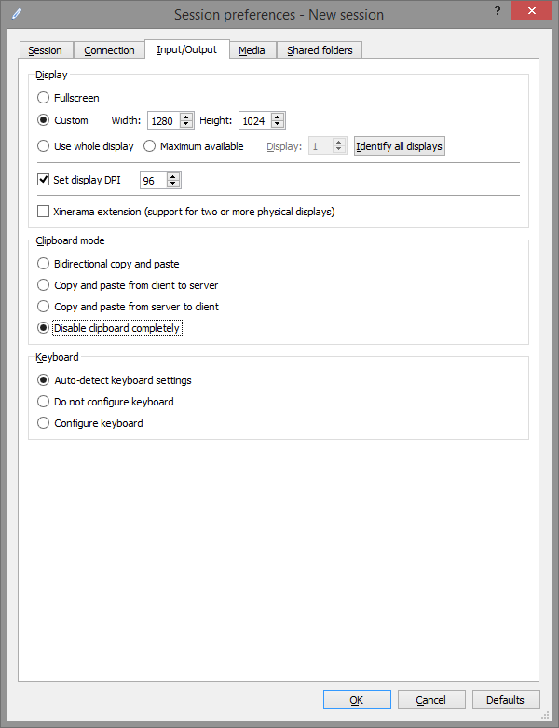

Figure 5

From the Media tab, un-tick all boxes, as per *figure 6:*

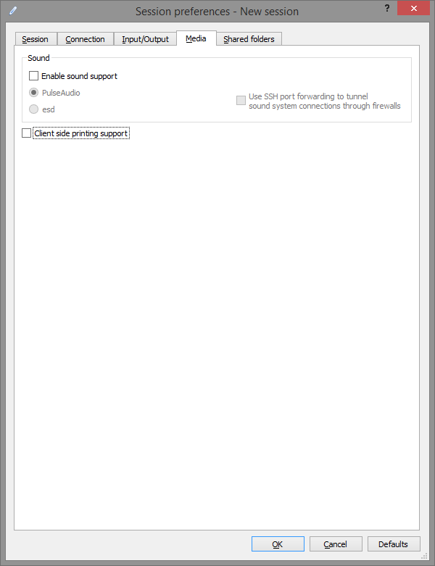

Figure 6

* 1. Connecting to the TRE

The public SSH key needs to be installed on the TRE virtual machine that X2Go will connect to. Send the public key by email to: [tre-support@manchester.ac.uk](mailto:tre-support@manchester.ac.uk)

1. Cross-referenced ISMS Documents

|  |  |  |
| --- | --- | --- |
| Number | Type | Title |
| ISMS-03-07 | ISMS\Policy & Guidance\TRE Operations - policy & guidance | TRE Password Policy |
| SOP-03-22 | ISMS\SOP\TRE Operations - SOP | Connecting to the TRE VPN with 2-FA |
| SOP-03-02 | ISMS\SOP\TRE Operations - SOP | TRE User Manual and Agreement |

1. Appendices

None